

Ministry of Skills Development, Employment and Labour Relations

**NVQ Level 5 in ICT – 2022**

**Name of**

**Project** Online Travel Agency

|  |  |  |  |  |  |  |  |  |  |  |  |  |  |  |  |  |
| --- | --- | --- | --- | --- | --- | --- | --- | --- | --- | --- | --- | --- | --- | --- | --- | --- |
| P | . | G | . | J | A | N | I | D | I |  | D | I | H | A | R | A |

**Student Name**

|  |  |  |  |  |  |  |  |  |  |  |  |  |  |  |  |  |
| --- | --- | --- | --- | --- | --- | --- | --- | --- | --- | --- | --- | --- | --- | --- | --- | --- |
| J | L | / | 2 | 2 | / | I | C | T | 5 | / | 1 | / | 0 | 0 | 1 | 4 |

**MIS**

**No**

|  |  |  |  |  |  |  |  |  |  |  |  |
| --- | --- | --- | --- | --- | --- | --- | --- | --- | --- | --- | --- |
| 1 | 9 | 9 | 9 | 7 | 6 | 4 | 0 | 2 | 2 | 4 | 4 |

**Student**

**NIC**

|  |  |  |  |  |  |  |  |  |  |
| --- | --- | --- | --- | --- | --- | --- | --- | --- | --- |
| 2 | 0 | 2 | 2 | / | 1 | 1 | / | 1 | 6 |

**Submission**

**Date**

**Center**

**Name** NVTI Baddegama

**Batch** 2022 First Batch

**Supervisor**

**Name** Mr. Nishantha Gamage

**Supervisor**

**Comments**

**Signature of**

**Supervisor**

|  |  |  |  |  |  |  |
| --- | --- | --- | --- | --- | --- | --- |
| **Official Use Only** | *Approved* |  |  | *Revised* | *Reject/Resubmit* |  |

1. **Problem Statement**

* With the prevailing social climate, planning trips is a very difficult task and involves a lot of cost and effort, where time management issues arise.
* Also, not knowing the basic facts necessary to choose the special places and places of importance in each country when choosing the countries while planning a trip. For example, distance, importance, other information, are very difficult to find.
  + **Who has the problem or who is the client/customer?**
* Admin
* user

1. **Problem Statement**

* **What is the problem**
* With the prevailing social climate, planning trips is a very difficult task and involves a lot of cost and effort, where time management issues arise.
* Also, not knowing the basic facts necessary to choose the special places and places of importance in each country when choosing the countries while planning a trip. For example, distance, importance, other information, are very difficult to find.
* **Who has the problem or who is the client/customer?**
* Admin
* User
* **What form can the resolution be?**
* Web Site

1. **Domain/ Problem area**

Due to the rapidly changing social conditions, there are many problems for consumers to plan trips. Also, not knowing the basic facts necessary to choose the special places and places of importance in each country when choosing the countries while planning a trip. For example, distance, importance, other information, are very difficult to find.

1. **Proposed Solution/ Scope**

People engage in recreational activities due to the mental stress that occurs in their daily activities with a personal tax for daily activities. Pays more attention to excursions.

The help of this website is to avoid the problems arising in the organization of excursions.

1. **Website to be followed**

[**https://www.srilanka.travel/**](https://www.srilanka.travel/)

1. **Methodologies going to be used?**

* Waterfall Methodology
* Easy to understand, easy to use
* Milestones are well understood
* Sets requirements stability
* Good for management control (plan, staff, track)
* Works well when quality is more important than cost or schedule

1. **Structure**

* **User panel**

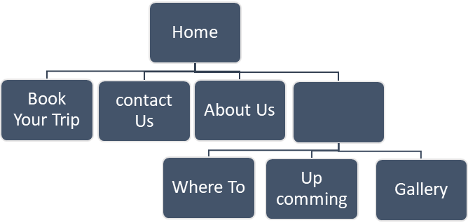

* **Admin Panel**

1. **Company LOGO**



1. **Weekly Basic project plan**

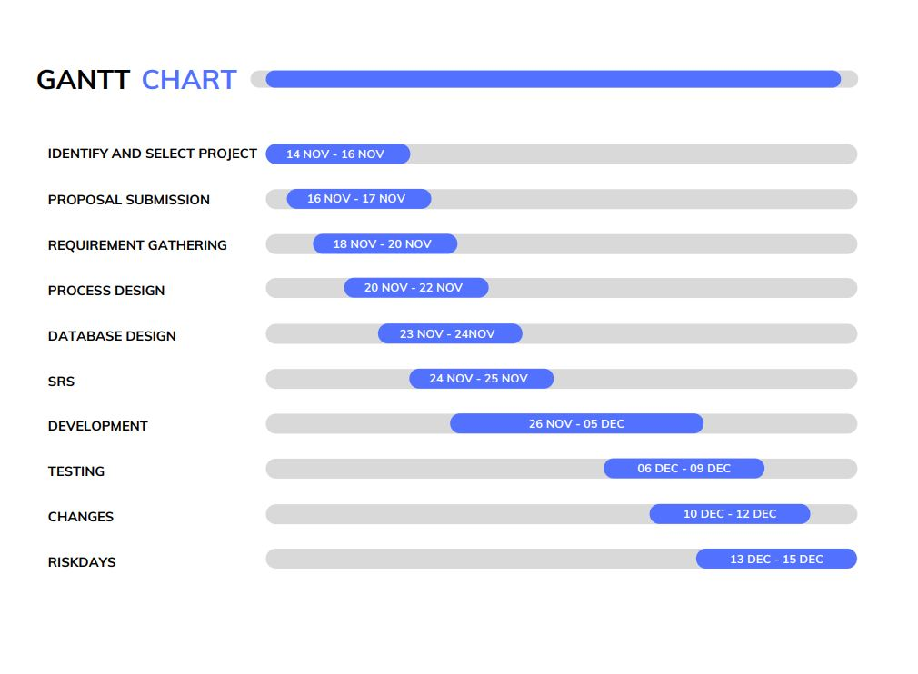

1. **Supervisor**
2. **Approval**